Dossier fonctionnel et technique



Date de début : 22/02/2020

Date de fin : 30/06/2020

I. Les données techniques

I.1 Le dictionnaire de données page 3

I.2 Modèle d’entité-association page 4

I.3 Schéma relationnel page 4

I.4 Le Script SQL page 5

II. Les fonctionnalités

II.1  Le backlog : la liste des fonctionnalités page 6

II.2 L’arborescence du site page 6

II.3 Les cas d’utilisations page 7

II.4 Maquette final page 7-8

III. Le dossier technique

III.1Focus sur 2 fonctionnalités page 9

III.2 Extrait de code commenté page 10

IV. Veille et auto-formation contextualisée

Mes veilles et résolution de mes problèmes page 11

V. Conduite de projet

V.1 Répartition des taches et compte rendu de réunions page 11

# I/ Les données

## 1.1dictionnaire de données

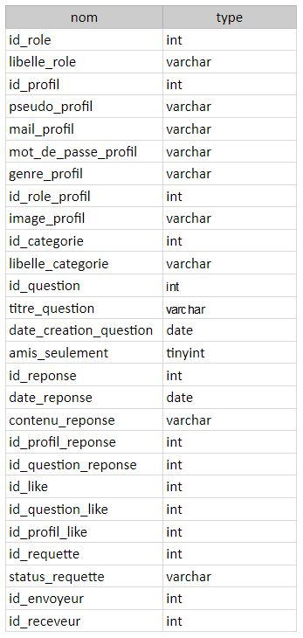

## 1.2 Modèle d’entité-association

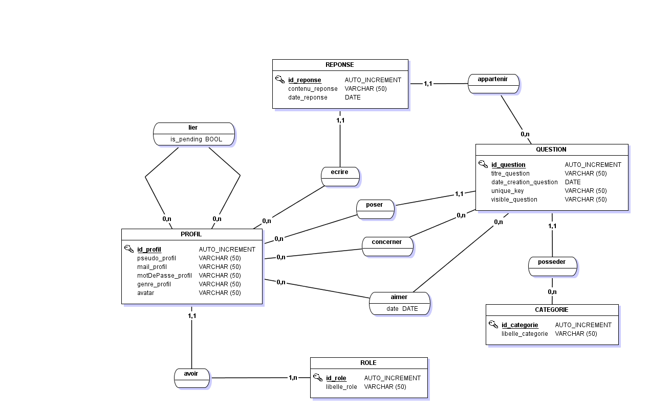

## 1.3Shemat relationnel

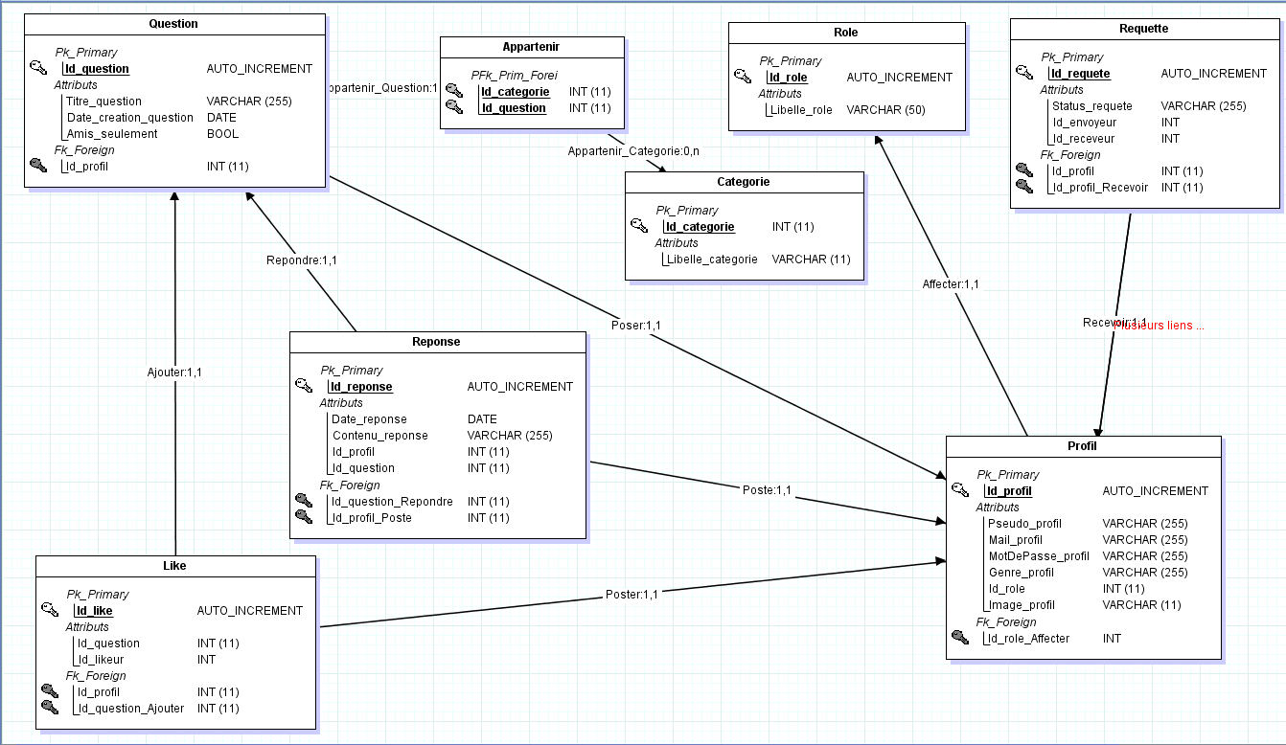

## 1.4 Script SQL

C[REATE](http://localhost/phpmyadmin/url.php?url=https://dev.mysql.com/doc/refman/5.5/en/create-table.html) [TABLE](http://localhost/phpmyadmin/url.php?url=https://dev.mysql.com/doc/refman/5.5/en/create-table.html) [IF](http://localhost/phpmyadmin/url.php?url=https://dev.mysql.com/doc/refman/5.5/en/control-flow-functions.html#function_if) [NOT](http://localhost/phpmyadmin/url.php?url=https://dev.mysql.com/doc/refman/5.5/en/logical-operators.html#operator_not) EXISTS `categorie` ( `Id_categorie` [int](http://localhost/phpmyadmin/url.php?url=https://dev.mysql.com/doc/refman/5.5/en/numeric-types.html)(11) [NOT](http://localhost/phpmyadmin/url.php?url=https://dev.mysql.com/doc/refman/5.5/en/logical-operators.html#operator_not) NULL AUTO_INCREMENT, `Libelle_categorie` [varchar](http://localhost/phpmyadmin/url.php?url=https://dev.mysql.com/doc/refman/5.5/en/string-types.html)(255) [CHARACTER](http://localhost/phpmyadmin/url.php?url=https://dev.mysql.com/doc/refman/5.5/en/charset.html) [SET](http://localhost/phpmyadmin/url.php?url=https://dev.mysql.com/doc/refman/5.5/en/charset.html) latin1 [NOT](http://localhost/phpmyadmin/url.php?url=https://dev.mysql.com/doc/refman/5.5/en/logical-operators.html#operator_not) NULL, PRIMARY KEY (`Id_categorie`) ) ENGINE=InnoDB AUTO_INCREMENT=51 [DEFAULT](http://localhost/phpmyadmin/url.php?url=https://dev.mysql.com/doc/refman/5.5/en/miscellaneous-functions.html#function_default) CHARSET=utf8

[INSERT](http://localhost/phpmyadmin/url.php?url=https://dev.mysql.com/doc/refman/5.5/en/insert.html) INTO `categorie` (`Id_categorie`, `Libelle_categorie`) [VALUES](http://localhost/phpmyadmin/url.php?url=https://dev.mysql.com/doc/refman/5.5/en/miscellaneous-functions.html#function_values) (1, 'automobile'), (2, 'pop culture'), (3, 'nature'), (4, 'cuisine'), (5, 'sciences'), (6, 'art')

[CREATE](http://localhost/phpmyadmin/url.php?url=https://dev.mysql.com/doc/refman/5.5/en/create-table.html) [TABLE](http://localhost/phpmyadmin/url.php?url=https://dev.mysql.com/doc/refman/5.5/en/create-table.html) [IF](http://localhost/phpmyadmin/url.php?url=https://dev.mysql.com/doc/refman/5.5/en/control-flow-functions.html#function_if) [NOT](http://localhost/phpmyadmin/url.php?url=https://dev.mysql.com/doc/refman/5.5/en/logical-operators.html#operator_not) EXISTS `likes` ( `Id_like` [int](http://localhost/phpmyadmin/url.php?url=https://dev.mysql.com/doc/refman/5.5/en/numeric-types.html)(11) [NOT](http://localhost/phpmyadmin/url.php?url=https://dev.mysql.com/doc/refman/5.5/en/logical-operators.html#operator_not) NULL AUTO_INCREMENT, `Id_question` [int](http://localhost/phpmyadmin/url.php?url=https://dev.mysql.com/doc/refman/5.5/en/numeric-types.html)(11) [NOT](http://localhost/phpmyadmin/url.php?url=https://dev.mysql.com/doc/refman/5.5/en/logical-operators.html#operator_not) NULL, `Id_likeur` [int](http://localhost/phpmyadmin/url.php?url=https://dev.mysql.com/doc/refman/5.5/en/numeric-types.html)(11) [NOT](http://localhost/phpmyadmin/url.php?url=https://dev.mysql.com/doc/refman/5.5/en/logical-operators.html#operator_not) NULL, PRIMARY KEY (`Id_like`), KEY `Id_question` (`Id_question`), KEY `Id_likeur` (`Id_likeur`) ) ENGINE=InnoDB AUTO_INCREMENT=6 [DEFAULT](http://localhost/phpmyadmin/url.php?url=https://dev.mysql.com/doc/refman/5.5/en/miscellaneous-functions.html#function_default) CHARSET=latin1

[CREATE](http://localhost/phpmyadmin/url.php?url=https://dev.mysql.com/doc/refman/5.5/en/create-table.html) [TABLE](http://localhost/phpmyadmin/url.php?url=https://dev.mysql.com/doc/refman/5.5/en/create-table.html) [IF](http://localhost/phpmyadmin/url.php?url=https://dev.mysql.com/doc/refman/5.5/en/control-flow-functions.html#function_if) [NOT](http://localhost/phpmyadmin/url.php?url=https://dev.mysql.com/doc/refman/5.5/en/logical-operators.html#operator_not) EXISTS `profil` ( `Id_profil` [int](http://localhost/phpmyadmin/url.php?url=https://dev.mysql.com/doc/refman/5.5/en/numeric-types.html)(11) [NOT](http://localhost/phpmyadmin/url.php?url=https://dev.mysql.com/doc/refman/5.5/en/logical-operators.html#operator_not) NULL AUTO_INCREMENT, `Pseudo_profil` [varchar](http://localhost/phpmyadmin/url.php?url=https://dev.mysql.com/doc/refman/5.5/en/string-types.html)(255) [CHARACTER](http://localhost/phpmyadmin/url.php?url=https://dev.mysql.com/doc/refman/5.5/en/charset.html) [SET](http://localhost/phpmyadmin/url.php?url=https://dev.mysql.com/doc/refman/5.5/en/charset.html) latin1 [NOT](http://localhost/phpmyadmin/url.php?url=https://dev.mysql.com/doc/refman/5.5/en/logical-operators.html#operator_not) NULL, `Mail_profil` [varchar](http://localhost/phpmyadmin/url.php?url=https://dev.mysql.com/doc/refman/5.5/en/string-types.html)(255) [CHARACTER](http://localhost/phpmyadmin/url.php?url=https://dev.mysql.com/doc/refman/5.5/en/charset.html) [SET](http://localhost/phpmyadmin/url.php?url=https://dev.mysql.com/doc/refman/5.5/en/charset.html) latin1 [NOT](http://localhost/phpmyadmin/url.php?url=https://dev.mysql.com/doc/refman/5.5/en/logical-operators.html#operator_not) NULL, `MotDePasse_profil` [varchar](http://localhost/phpmyadmin/url.php?url=https://dev.mysql.com/doc/refman/5.5/en/string-types.html)(255) [CHARACTER](http://localhost/phpmyadmin/url.php?url=https://dev.mysql.com/doc/refman/5.5/en/charset.html) [SET](http://localhost/phpmyadmin/url.php?url=https://dev.mysql.com/doc/refman/5.5/en/charset.html) latin1 [NOT](http://localhost/phpmyadmin/url.php?url=https://dev.mysql.com/doc/refman/5.5/en/logical-operators.html#operator_not) NULL, `Genre_profil` [varchar](http://localhost/phpmyadmin/url.php?url=https://dev.mysql.com/doc/refman/5.5/en/string-types.html)(50) [CHARACTER](http://localhost/phpmyadmin/url.php?url=https://dev.mysql.com/doc/refman/5.5/en/charset.html) [SET](http://localhost/phpmyadmin/url.php?url=https://dev.mysql.com/doc/refman/5.5/en/charset.html) latin1 [NOT](http://localhost/phpmyadmin/url.php?url=https://dev.mysql.com/doc/refman/5.5/en/logical-operators.html#operator_not) NULL, `Id_role` [int](http://localhost/phpmyadmin/url.php?url=https://dev.mysql.com/doc/refman/5.5/en/numeric-types.html)(11) [NOT](http://localhost/phpmyadmin/url.php?url=https://dev.mysql.com/doc/refman/5.5/en/logical-operators.html#operator_not) NULL, `Image_profil` [varchar](http://localhost/phpmyadmin/url.php?url=https://dev.mysql.com/doc/refman/5.5/en/string-types.html)(255) [NOT](http://localhost/phpmyadmin/url.php?url=https://dev.mysql.com/doc/refman/5.5/en/logical-operators.html#operator_not) NULL [DEFAULT](http://localhost/phpmyadmin/url.php?url=https://dev.mysql.com/doc/refman/5.5/en/miscellaneous-functions.html#function_default) 'https://i2.wp.com/yellowsummary.com/wp-content/uploads/2019/02/Icone-profil.png?fit=512%2C512&ssl=1', PRIMARY KEY (`Id_profil`), KEY `#Id_role` (`Id_role`) ) ENGINE=InnoDB AUTO_INCREMENT=26 [DEFAULT](http://localhost/phpmyadmin/url.php?url=https://dev.mysql.com/doc/refman/5.5/en/miscellaneous-functions.html#function_default) CHARSET=utf8

[CREATE](http://localhost/phpmyadmin/url.php?url=https://dev.mysql.com/doc/refman/5.5/en/create-table.html) [TABLE](http://localhost/phpmyadmin/url.php?url=https://dev.mysql.com/doc/refman/5.5/en/create-table.html) [IF](http://localhost/phpmyadmin/url.php?url=https://dev.mysql.com/doc/refman/5.5/en/control-flow-functions.html#function_if) [NOT](http://localhost/phpmyadmin/url.php?url=https://dev.mysql.com/doc/refman/5.5/en/logical-operators.html#operator_not) EXISTS `question` ( `Id_question` [int](http://localhost/phpmyadmin/url.php?url=https://dev.mysql.com/doc/refman/5.5/en/numeric-types.html)(11) [NOT](http://localhost/phpmyadmin/url.php?url=https://dev.mysql.com/doc/refman/5.5/en/logical-operators.html#operator_not) NULL AUTO_INCREMENT, `Titre_question` [varchar](http://localhost/phpmyadmin/url.php?url=https://dev.mysql.com/doc/refman/5.5/en/string-types.html)(255) [CHARACTER](http://localhost/phpmyadmin/url.php?url=https://dev.mysql.com/doc/refman/5.5/en/charset.html) [SET](http://localhost/phpmyadmin/url.php?url=https://dev.mysql.com/doc/refman/5.5/en/charset.html) latin1 [NOT](http://localhost/phpmyadmin/url.php?url=https://dev.mysql.com/doc/refman/5.5/en/logical-operators.html#operator_not) NULL, `Date_creation_question` [date](http://localhost/phpmyadmin/url.php?url=https://dev.mysql.com/doc/refman/5.5/en/date-and-time-types.html) [NOT](http://localhost/phpmyadmin/url.php?url=https://dev.mysql.com/doc/refman/5.5/en/logical-operators.html#operator_not) NULL, `Id_profil` [int](http://localhost/phpmyadmin/url.php?url=https://dev.mysql.com/doc/refman/5.5/en/numeric-types.html)(11) [NOT](http://localhost/phpmyadmin/url.php?url=https://dev.mysql.com/doc/refman/5.5/en/logical-operators.html#operator_not) NULL, `Id_categorie` [int](http://localhost/phpmyadmin/url.php?url=https://dev.mysql.com/doc/refman/5.5/en/numeric-types.html)(11) [NOT](http://localhost/phpmyadmin/url.php?url=https://dev.mysql.com/doc/refman/5.5/en/logical-operators.html#operator_not) NULL, `Amis_seulement` [tinyint](http://localhost/phpmyadmin/url.php?url=https://dev.mysql.com/doc/refman/5.5/en/numeric-types.html)(1) [NOT](http://localhost/phpmyadmin/url.php?url=https://dev.mysql.com/doc/refman/5.5/en/logical-operators.html#operator_not) NULL [DEFAULT](http://localhost/phpmyadmin/url.php?url=https://dev.mysql.com/doc/refman/5.5/en/miscellaneous-functions.html#function_default) '0', PRIMARY KEY (`Id_question`), KEY `#Id_profil` (`Id_profil`), KEY `Id_categorie` (`Id_categorie`) ) ENGINE=InnoDB AUTO_INCREMENT=177 [DEFAULT](http://localhost/phpmyadmin/url.php?url=https://dev.mysql.com/doc/refman/5.5/en/miscellaneous-functions.html#function_default) CHARSET=utf8

[CREATE](http://localhost/phpmyadmin/url.php?url=https://dev.mysql.com/doc/refman/5.5/en/create-table.html) [TABLE](http://localhost/phpmyadmin/url.php?url=https://dev.mysql.com/doc/refman/5.5/en/create-table.html) [IF](http://localhost/phpmyadmin/url.php?url=https://dev.mysql.com/doc/refman/5.5/en/control-flow-functions.html#function_if) [NOT](http://localhost/phpmyadmin/url.php?url=https://dev.mysql.com/doc/refman/5.5/en/logical-operators.html#operator_not) EXISTS `reponse` ( `Id_reponse` [int](http://localhost/phpmyadmin/url.php?url=https://dev.mysql.com/doc/refman/5.5/en/numeric-types.html)(11) [NOT](http://localhost/phpmyadmin/url.php?url=https://dev.mysql.com/doc/refman/5.5/en/logical-operators.html#operator_not) NULL AUTO_INCREMENT, `Contenu_reponse` [varchar](http://localhost/phpmyadmin/url.php?url=https://dev.mysql.com/doc/refman/5.5/en/string-types.html)(255) [CHARACTER](http://localhost/phpmyadmin/url.php?url=https://dev.mysql.com/doc/refman/5.5/en/charset.html) [SET](http://localhost/phpmyadmin/url.php?url=https://dev.mysql.com/doc/refman/5.5/en/charset.html) latin1 [NOT](http://localhost/phpmyadmin/url.php?url=https://dev.mysql.com/doc/refman/5.5/en/logical-operators.html#operator_not) NULL, `Date_reponse` [date](http://localhost/phpmyadmin/url.php?url=https://dev.mysql.com/doc/refman/5.5/en/date-and-time-types.html) [NOT](http://localhost/phpmyadmin/url.php?url=https://dev.mysql.com/doc/refman/5.5/en/logical-operators.html#operator_not) NULL, `Id_profil` [int](http://localhost/phpmyadmin/url.php?url=https://dev.mysql.com/doc/refman/5.5/en/numeric-types.html)(11) [NOT](http://localhost/phpmyadmin/url.php?url=https://dev.mysql.com/doc/refman/5.5/en/logical-operators.html#operator_not) NULL, `Id_question` [int](http://localhost/phpmyadmin/url.php?url=https://dev.mysql.com/doc/refman/5.5/en/numeric-types.html)(11) [NOT](http://localhost/phpmyadmin/url.php?url=https://dev.mysql.com/doc/refman/5.5/en/logical-operators.html#operator_not) NULL, PRIMARY KEY (`Id_reponse`), KEY `#Id_profil` (`Id_profil`), KEY `#Id_question` (`Id_question`) ) ENGINE=InnoDB AUTO_INCREMENT=2 [DEFAULT](http://localhost/phpmyadmin/url.php?url=https://dev.mysql.com/doc/refman/5.5/en/miscellaneous-functions.html#function_default) CHARSET=utf8

[CREATE](http://localhost/phpmyadmin/url.php?url=https://dev.mysql.com/doc/refman/5.5/en/create-table.html) [TABLE](http://localhost/phpmyadmin/url.php?url=https://dev.mysql.com/doc/refman/5.5/en/create-table.html) [IF](http://localhost/phpmyadmin/url.php?url=https://dev.mysql.com/doc/refman/5.5/en/control-flow-functions.html#function_if) [NOT](http://localhost/phpmyadmin/url.php?url=https://dev.mysql.com/doc/refman/5.5/en/logical-operators.html#operator_not) EXISTS `requete` ( `Id_requete` [int](http://localhost/phpmyadmin/url.php?url=https://dev.mysql.com/doc/refman/5.5/en/numeric-types.html)(11) [NOT](http://localhost/phpmyadmin/url.php?url=https://dev.mysql.com/doc/refman/5.5/en/logical-operators.html#operator_not) NULL AUTO_INCREMENT, `Status_requete` [varchar](http://localhost/phpmyadmin/url.php?url=https://dev.mysql.com/doc/refman/5.5/en/string-types.html)(255) [NOT](http://localhost/phpmyadmin/url.php?url=https://dev.mysql.com/doc/refman/5.5/en/logical-operators.html#operator_not) NULL [DEFAULT](http://localhost/phpmyadmin/url.php?url=https://dev.mysql.com/doc/refman/5.5/en/miscellaneous-functions.html#function_default) 'attente', `Id_envoyeur` [int](http://localhost/phpmyadmin/url.php?url=https://dev.mysql.com/doc/refman/5.5/en/numeric-types.html)(11) [NOT](http://localhost/phpmyadmin/url.php?url=https://dev.mysql.com/doc/refman/5.5/en/logical-operators.html#operator_not) NULL, `Id_receveur` [int](http://localhost/phpmyadmin/url.php?url=https://dev.mysql.com/doc/refman/5.5/en/numeric-types.html)(11) [NOT](http://localhost/phpmyadmin/url.php?url=https://dev.mysql.com/doc/refman/5.5/en/logical-operators.html#operator_not) NULL, PRIMARY KEY (`Id_requete`), KEY `Id_envoyeur` (`Id_envoyeur`), KEY `Id_receveur` (`Id_receveur`) ) ENGINE=InnoDB AUTO_INCREMENT=3 [DEFAULT](http://localhost/phpmyadmin/url.php?url=https://dev.mysql.com/doc/refman/5.5/en/miscellaneous-functions.html#function_default) CHARSET=latin1

[CREATE](http://localhost/phpmyadmin/url.php?url=https://dev.mysql.com/doc/refman/5.5/en/create-table.html) [TABLE](http://localhost/phpmyadmin/url.php?url=https://dev.mysql.com/doc/refman/5.5/en/create-table.html) [IF](http://localhost/phpmyadmin/url.php?url=https://dev.mysql.com/doc/refman/5.5/en/control-flow-functions.html#function_if) [NOT](http://localhost/phpmyadmin/url.php?url=https://dev.mysql.com/doc/refman/5.5/en/logical-operators.html#operator_not) EXISTS `role` ( `Id_role` [int](http://localhost/phpmyadmin/url.php?url=https://dev.mysql.com/doc/refman/5.5/en/numeric-types.html)(11) [NOT](http://localhost/phpmyadmin/url.php?url=https://dev.mysql.com/doc/refman/5.5/en/logical-operators.html#operator_not) NULL AUTO_INCREMENT, `Libelle_role` [varchar](http://localhost/phpmyadmin/url.php?url=https://dev.mysql.com/doc/refman/5.5/en/string-types.html)(50) [CHARACTER](http://localhost/phpmyadmin/url.php?url=https://dev.mysql.com/doc/refman/5.5/en/charset.html) [SET](http://localhost/phpmyadmin/url.php?url=https://dev.mysql.com/doc/refman/5.5/en/charset.html) latin1 [NOT](http://localhost/phpmyadmin/url.php?url=https://dev.mysql.com/doc/refman/5.5/en/logical-operators.html#operator_not) NULL, PRIMARY KEY (`Id_role`) ) ENGINE=InnoDB AUTO_INCREMENT=3 [DEFAULT](http://localhost/phpmyadmin/url.php?url=https://dev.mysql.com/doc/refman/5.5/en/miscellaneous-functions.html#function_default) CHARSET=utf8

[INSERT](http://localhost/phpmyadmin/url.php?url=https://dev.mysql.com/doc/refman/5.5/en/insert.html) INTO `role` (`Id_role`, `Libelle_role`) [VALUES](http://localhost/phpmyadmin/url.php?url=https://dev.mysql.com/doc/refman/5.5/en/miscellaneous-functions.html#function_values) (1, 'utilisateur'), (2, 'administrateur')

[ALTER](http://localhost/phpmyadmin/url.php?url=https://dev.mysql.com/doc/refman/5.5/en/alter-table.html) [TABLE](http://localhost/phpmyadmin/url.php?url=https://dev.mysql.com/doc/refman/5.5/en/alter-table.html) `likes` ADD CONSTRAINT `likes_ibfk_1` FOREIGN KEY (`Id_likeur`) REFERENCES `profil` (`Id_profil`)

[ALTER](http://localhost/phpmyadmin/url.php?url=https://dev.mysql.com/doc/refman/5.5/en/alter-table.html) [TABLE](http://localhost/phpmyadmin/url.php?url=https://dev.mysql.com/doc/refman/5.5/en/alter-table.html) `profil` ADD CONSTRAINT `FK_#Id_role` FOREIGN KEY (`Id_role`) REFERENCES `role` (`Id_role`)

[ALTER](http://localhost/phpmyadmin/url.php?url=https://dev.mysql.com/doc/refman/5.5/en/alter-table.html) [TABLE](http://localhost/phpmyadmin/url.php?url=https://dev.mysql.com/doc/refman/5.5/en/alter-table.html) `reponse` ADD CONSTRAINT `FK_#Id_profil2` FOREIGN KEY (`Id_profil`) REFERENCES `profil` (`Id_profil`), ADD CONSTRAINT `FK_#Id_question` FOREIGN KEY (`Id_question`) REFERENCES `question` (`Id_question`)

[ALTER](http://localhost/phpmyadmin/url.php?url=https://dev.mysql.com/doc/refman/5.5/en/alter-table.html) [TABLE](http://localhost/phpmyadmin/url.php?url=https://dev.mysql.com/doc/refman/5.5/en/alter-table.html) `requete` ADD CONSTRAINT `requete_ibfk_1` FOREIGN KEY (`Id_envoyeur`) REFERENCES `profil` (`Id_profil`),ADD CONSTRAINT `requete_ibfk_2` FOREIGN KEY (`Id_receveur`) REFERENCES `profil` (`Id_profil`)

# II) Les fonctionnalités

## 2.1 backlog : liste des fonctionnalités

- créer un compte

- se connecter/déconnecter

- poser des questions

- répondre à des questions

- mettre des "j'aimes" à des questions

- ajouter des amis

- poser des questions uniquement à nos amis

- modifier les informations du profil

- se désinscrire

## 2.2l’arborescence

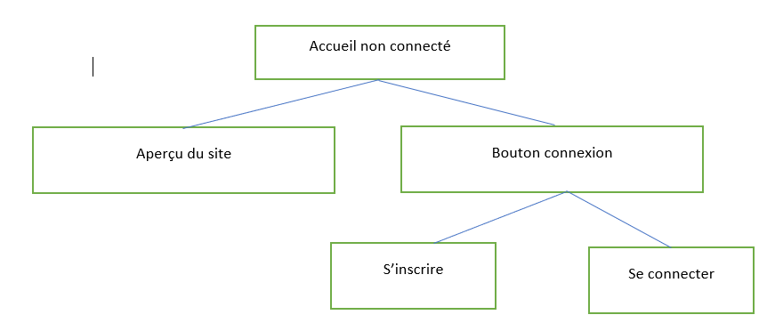

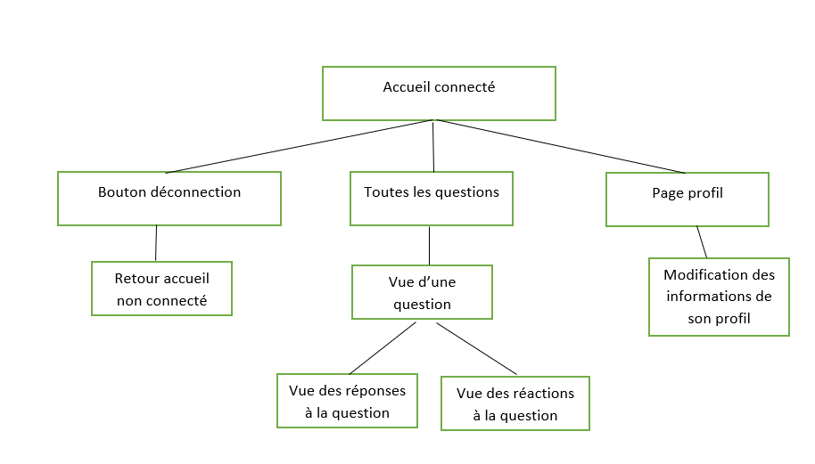

## 2.3 les cas d’utilisation



Modifier son profile

Réagir à une question (like)

Répondre à une question

Poser une question

Envoyer une demande d’ami

Inscription sur le site

Accepter/décliner demande d’ami

Suppression du compte

Utilisateur

## 2.4 les maquettes du site final

Page d’accueil (imposé par la volonté du client)



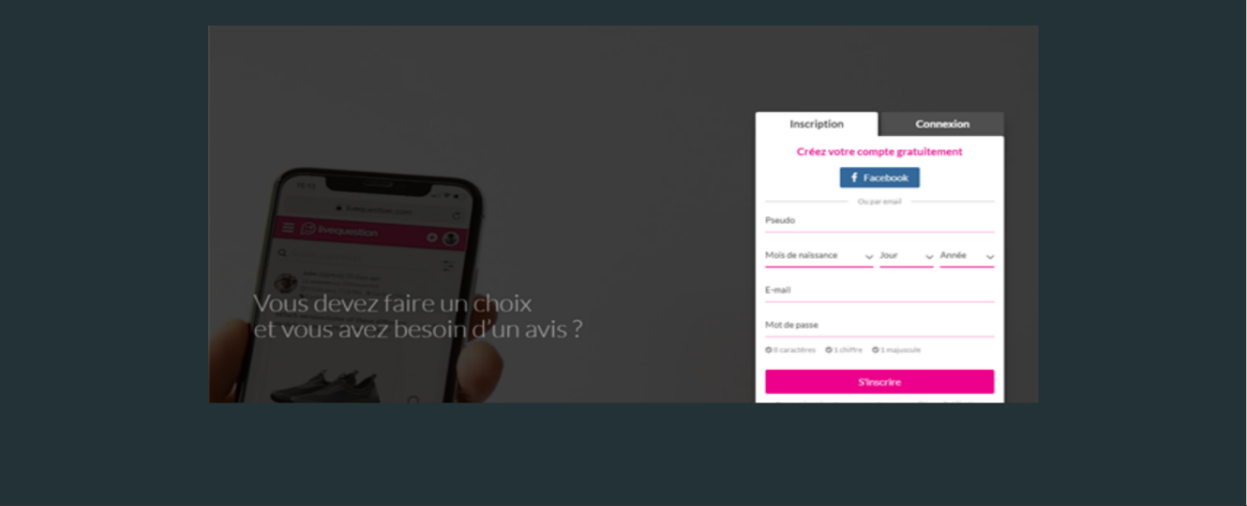



Page d'affichage des questions

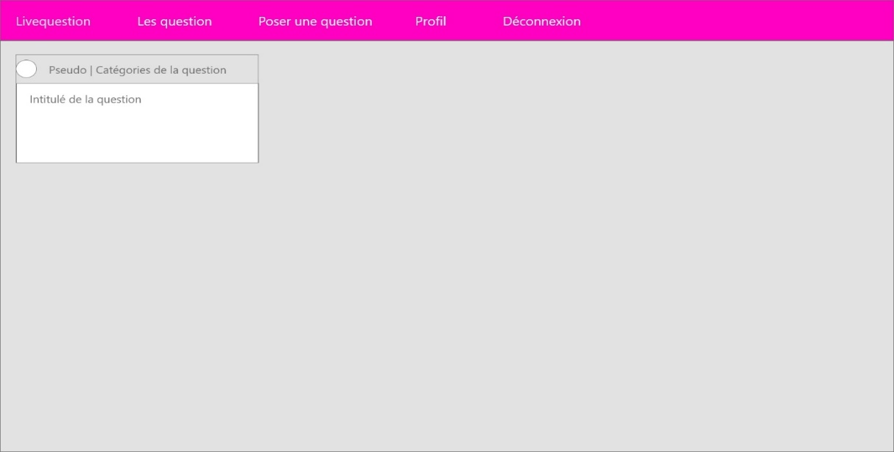

Page du profil

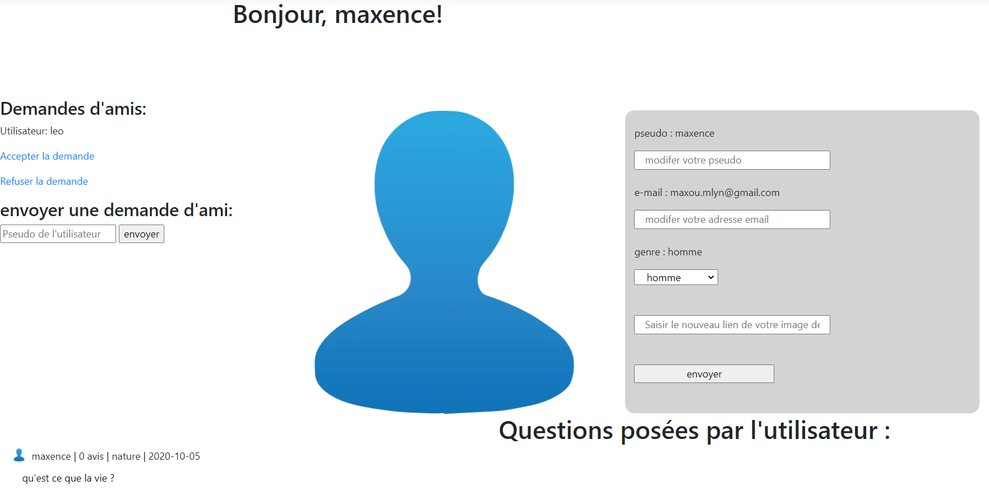

# III) dossier technique

## 3.1 Focus sur 2 fonctionnalités

Fonctionnalité : poser une question à ses amis

En cochant une case, nous pouvons poser une question uniquement à nos amis.

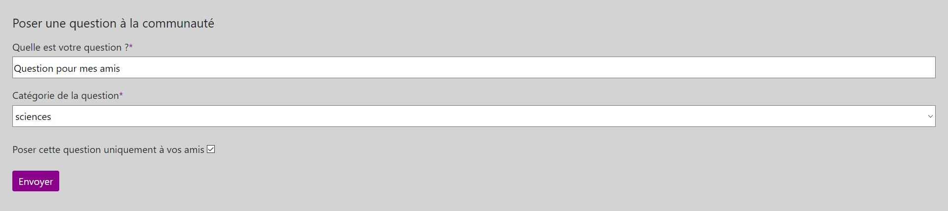

Fonctionnalité accepter ou refuser une demande d’ami

Il suffit de rentrer le nom d’utilisateur de notre ami pour lui envoyer une demande. Il a le choix ensuite sur la page de son profil de l’accepter ou de la décliner.

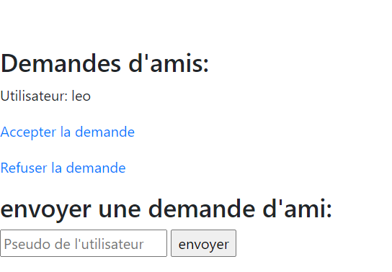

## 3.2 Code commenté

Fonctionnalité : poser une question à ses amis

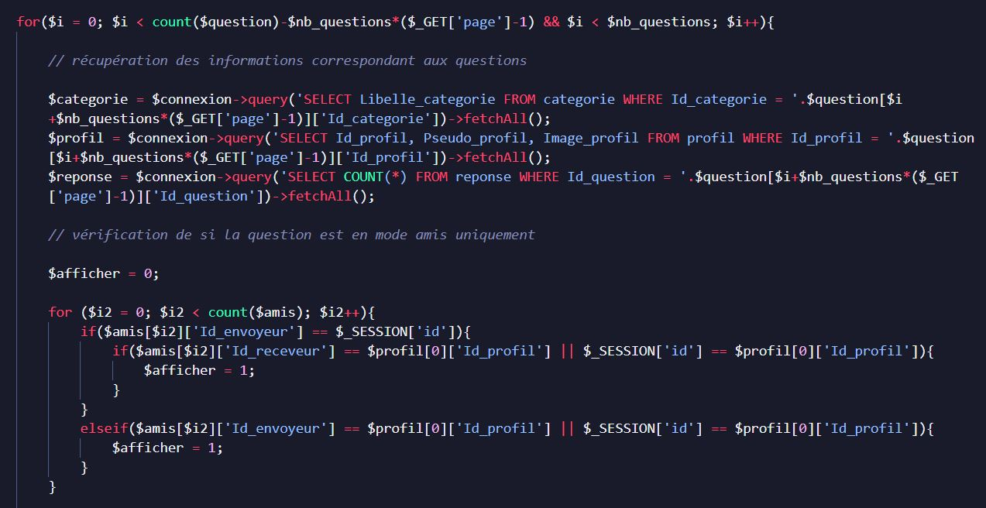

Fonctionnalité accepter ou refuser une demande d’ami

Ici on récupère l’identifiant de l’envoyeur directement dans la session lancée

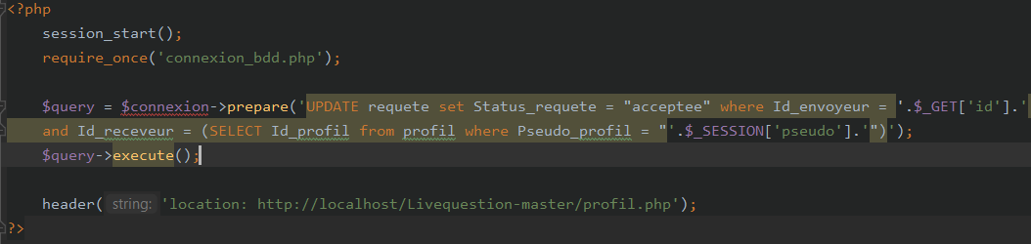

Ici on récupère l’identifiant du receveur dans la table profil

La seule différence est l’affectation à la variable Status_requette à refusée ou acceptée

# IV) Veille ou auto-formation contextualisée

Pour ce projet j’ai réalisé des veilles sur certaines fonctionnalités comme le hachage de mot de passe ainsi que des recherches sur le fonctionnement d’une session lorsqu’un utilisateur utilise un site. J’ai aussi sollicité de multiples fois l’aide de notre encadrant de projet, un CTO chez MentalWork.

# V) Conduite de projet

## 5.1 Répartition des taches et compte rendu de réunions

La répartition des taches s’est faite par groupe, nous étions très souvent 2 à réaliser un commit et nous nous réunissions sur discord pour parler de nos éventuels problèmes. Les réunions se passaient en groupe de projet mais le reste du temps nous nous connections aussi avec nos collègues pour facilité la communication. Il n’y avait donc pas de réunions obligatoires hormis les comptes rendu a faire a notre tuteure projet Jeff Martins Jaquelot.

La répartition des taches du projet est disponible ici : <https://github.com/LeoBruant/Livequestion/issues>